

De La Salle University

Gokongwei College of Engineering

Electronics and Communications Engineering Department

Bed no Breakfast

LBYCPG2/ EQ4

1800-2100 T

Submitted by:

Mayuga, Keenan Eliot L.

Jadman, Daine Janssen R.

Submitted to:

Engr. Bernard G. Yasay

Date Submitted:

September 23, 2021

I. Introduction

Background of the Project

The team developed a project based on a bed and breakfast business. This website application accommodates guests based on their preferences. This could be either a house, inn, or any small-scale lodging establishment in which creating a reservation is needed. Therefore, it would require users to register an account with their information and login so that they could book a reservation. Furthermore, the user can also check which rooms or houses are available for checking in. For the B&B system, it is able to store the reservation schedule and bookings of each user. It also stores user information such as first name, last name, email, phone number, and password.

Objectives

1. Have a login system for the user to enter the website
2. Create a friendly and fully functional website to book a B&B
3. Connect a MySQL database to the website using PHP

Problem:

The application aims to solve issues encountered by customers when they are looking for a cheaper place to stay. It also offers a variety of choices so that customers can pick a breakfast and bed based on their preferences. Lastly, it makes it easy for the website owner to manage the bookings of each customer.

Significance of the System:

The significance of a bed and breakfast system is that it assists the website owner in keeping track of all the bookings for several different Bed and Breakfasts. It also makes it easier for bed and breakfast owners to advertise their lodgings in the application so that they can gain customers.

Scope and Limitations of the Study

The software is able to store user information so that once they register their accounts, they are able to login after. It would also prevent users from accessing the site if they input an incorrect username or password; additionally, it would block access if the account they used to login has not been registered yet. On the main page, users can click on the navigation bar to quickly jump through the page. For reserving, below the navigation bar, there is a mini calendar that allows the user to input the dates they would like to check in and check out. This feature leads the user to the available rooms below and the check in and check out dates they initially entered would be displayed. A confirmation pop up would appear as well when the user has booked a lodging. Lastly, there is a sign out button that would log the user out and bring them back to the login screen.

As for limitations, the software cannot further contact the user through email as the team does not have the knowledge yet to do so. Since it is only a one page website there is a limited amount of information to place so that it would not look overloaded.

II. Project Details

Functionality

The start is a login page with a simple login system wherein it would lead the user to the main site if the input (email and password) matches the information in the database. If the user has no account yet, then the user may register and the details inputted will be placed in the users table in the database.

The main site created utilizes a “One Page Wonder” where the whole page consists of all the things needed in one page. With the navigation bar on the top, the user can scroll through different sections of the page with a smooth scrolling effect. The site uses a fair amount of css for it to function properly; hence, the navigation bar has section headers (Home, Rooms, Reviews, Contact Us) to move to the desired section with a smooth scroll effect. The first thing the user can see is the date inputs (with a mini calendar display) and a check availability button. When the dates are inputted and the button is pressed, it will bring the user to the rooms section with the inputted dates from the start. The user can see the rooms with the prices per night and a short description fetched from the rooms table in the database. When the user presses the book now button, it will notify the user that the booking has been successful and it will reflect in the orders tables in the database. When scrolling further down, it will be seen that there is a reviews section where people who have used the service give their feedback. The contact us section leads to the footer where it has team members’ names linked to their facebook accounts. Lastly, there is a sign out button where the user can log out of the site and would lead back to the login page.

Codes

1. login.php

<?php

require_once "function.php";

/*

*

* */

session_start();

$msg = "";

$database = new database();

if (isset($_POST['email'])) $email = $_POST['email'];

if (isset($_POST['password'])) $password = $_POST['password'];

if (isset($email) && isset($password)) {

if (!empty($email) && !empty($password)) {

/*

* validate

* */

$user = $database->get_user_row($email);

if ($user) {

if ($password == $user['password']) {

$_SESSION['userid'] = $user['userid'];

header("Location: " . BASE_URL . "home.php");

} else {

$msg = "Wrong password is entered. Please enter correct password.";

}

} else {

$msg = "Wrong email is entered. Please enter correct email";

}

}

}

?>

<html>

<link href="./css/bootstrap.min.css" rel="stylesheet" type="text/css">

<link href="loginCSS.css" rel="stylesheet" type="text/css">

<?php

if ($msg) {

?>

<div class="alert alert-danger"><strong>ERROR!</strong><?php echo $msg; ?></div>

<?php

}

?>

<h2>Bed no Breakfast</h2>

<div class="container" id="container">

<div class="form-container sign-in-container">

<form action="<?php echo $_SERVER['PHP_SELF']; ?>" method="post">

<h1>Log in</h1>

<div class="social-container">

</div>

<input type="email" placeholder="Email" name="email" required/>

<input type="password" placeholder="Password" name="password" required/>

<button type="submit">Log in</button>

</form>

</div>

<form action="registration.php" method="post">

<div class="overlay-container">

<div class="overlay">

<div class="overlay-panel overlay-right">

<h1>Hello, Traveler!</h1>

<p>Enter your personal details and start your journey with us</p>

<button class="ghost" id="signUp">Register Now</button>

</div>

</div>

</div>

</form>

</div>

<footer>

<p>

LBYCPG2 Project <i class="fa fa-heart"></i> by

<a target="_blank" href="https://www.facebook.com/keenan.mayuga">Keenan Mayuga</a>

and

<a target="_blank" href="https://www.facebook.com/dainejadman.1/">Daine Jadman</a>.

</p>

</footer>

</html>

1. registration.php

<?php

require_once "function.php";

/*

*

* */

session_start();

$msg = "";

$database = new database();

if (isset($_POST['firstname'])) $firstname = $_POST['firstname'];

if (isset($_POST['lastname'])) $lastname = $_POST['lastname'];

if (isset($_POST['phonenumber'])) $phonenumber = $_POST['phonenumber'];

if (isset($_POST['email'])) $email = $_POST['email'];

if (isset($_POST['password'])) $password = $_POST['password'];

if (isset($_POST['confirmpassword'])) $confirmpassword = $_POST['confirmpassword'];

if (isset($firstname) && isset($lastname) && isset($phonenumber) && isset($email) && isset($password) && isset($confirmpassword)) {

if (!empty($firstname) && !empty($lastname) && !empty($phonenumber) && !empty($email) && !empty($password) && !empty($confirmpassword)) {

/*

* validate

* */

if($password <> $confirmpassword) {

$msg = "Please confirm correct password";

}

else {

$result = $database->insert_user_row($firstname, $lastname, $phonenumber, $email, $password);

var_dump($result);

if (!$result) {

$msg = "Registeration failed. Please try again.";

} else {

header("Location: " . BASE_URL . "registercomplete.php");

}

}

}

}

?>

<html>

<link href="./css/bootstrap.min.css" rel="stylesheet" type="text/css">

<link href="loginCSS.css" rel="stylesheet" type="text/css">

<?php

if ($msg) {

?>

<div class="alert alert-danger"><strong>ERROR!</strong><?php echo $msg; ?></div>

<?php

}

?>

<h2>Bed no Breakfast</h2>

<div class="container" id="container">

<div class="form-container sign-in-container">

<form action="<?php echo $_SERVER['PHP_SELF']?>" method="post">

<h1>Create Account</h1>

<div class="social-container">

</div>

<input type="text" placeholder="First Name" name="firstname" required/>

<input type="text" placeholder="Last Name" name="lastname" required/>

<input type="email" placeholder="Email" name="email" required/>

<input type="text" placeholder="Phone Number" name="phonenumber" required/>

<input type="password" placeholder="Password" name="password" required/>

<input type="password" placeholder="Confirm Password" name="confirmpassword" required/>

<button type="submit">Register</button>

</form>

</div>

<form action="login.php" method="post">

<div class="overlay-container">

<div class="overlay">

<div class="overlay-panel overlay-right">

<h1>Welcome Back!</h1>

<p>To keep connected with us please login with your personal info</p>

<button class="ghost" id="signIn">Log in</button>

</div>

</div>

</div>

</form>

</div>

<footer>

<p>

LBYCPG2 Project <i class="fa fa-heart"></i> by

<a target="_blank" href="https://www.facebook.com/keenan.mayuga">Keenan Mayuga</a>

and

<a target="_blank" href="https://www.facebook.com/dainejadman.1/">Daine Jadman</a>.

</p>

</footer>

</html>

1. registrationcomplete.php

<html>

<link href="LoginCSS.css" rel = "stylesheet" type = "text/css">

<h2>Bed no Breakfast</h2>

<div class="container" id="container">

<form action= "login.php" method="post">

<div class="overlay-container-center">

<div class="overlay">

<div class="overlay-panel overlay-center">

<h1>Registration Complete!</h1>

<p>Login here to continue</p>

<button class="ghost" id="signIn">Log In</button>

</div>

</div>

</div>

</form>

</div>

<footer>

<p>

LBYCPG2 Project <i class="fa fa-heart"></i> by

<a target="_blank" href="https://www.facebook.com/keenan.mayuga">Keenan Mayuga</a>

and

<a target="_blank" href="https://www.facebook.com/dainejadman.1/">Daine Jadman</a>.

</p>

</footer>

</html>

1. function.php

<?php

require_once "constants.php";

class database {

private $db_host;

private $db_name;

private $db_user;

private $db_password;

public function __construct()

{

$this->db_host = DB_HOST;

$this->db_name = DB_NAME;

$this->db_user = DB_USER;

$this->db_password = DB_PASSWORD;

$this->conn = mysqli_connect($this->db_host, $this->db_user, $this->db_password, $this->db_name);

}

function get_user_row($email = ""){

$sql = "SELECT * FROM users WHERE email='$email'";

$result = $this->conn->query($sql);

if($result) {

if ($result->num_rows > 0) {

return $result->fetch_assoc();

} else {

return false;

}

}

return false;

}

function insert_user_row($firstname = "", $lastname = "", $phonenumber = '', $email = "", $password = "") {

$sql = "INSERT INTO users (firstname, lastname, phonenumber, email, password) VALUES ('$firstname', '$lastname', '$phonenumber', '$email', '$password')";

$result = $this->conn->query($sql);

return $result;

}

function get_all_rooms(){

$sql = "SELECT * FROM rooms";

$result = $this->conn->query($sql);

if($result) {

if ($result->num_rows > 0) {

while($row = $result->fetch_assoc()) {

$result1[] = $row;

}

return $result1;

} else {

return false;

}

}

return false;

}

function insert_order($id, $user_id, $check_in, $check_out) {

$sql = "INSERT INTO orders (user_id, bnb_id, date_in, date_out) VALUES ('$id', '$user_id', '$check_in', '$check_out' )";

$result = $this->conn->query($sql);

return $result;

}

}

function isLogin(){

if(isset($_SESSION['userid']) AND $_SESSION['userid'] <> ""){

return true;

}

return false;

}

1. constants.php

<?php

/*

* base_url constant

*

* */

defined("BASE_URL") OR define("BASE_URL", "http://localhost/project/");

/*

* database constants

* */

defined("DB_HOST") OR define("DB_HOST", "localhost");

defined("DB_USER") OR define("DB_USER", "root");

defined("DB_NAME") OR define("DB_NAME", "bnb_db");

defined("DB_PASSWORD") OR define("DB_PASSWORD", "");

1. index.php

<?php

require_once "constants.php";

header("Location: ".BASE_URL."login.php");

1. home.php

<?php

require_once "function.php";

/*

* login

* */

session_start();

if (!isLogin()) {

header("Location: " . BASE_URL . "login.php");

}

$msg = "";

$database = new database();

$rooms = $database->get_all_rooms();

if (isset($_GET['check-in']) && isset($_GET['check-out'])) {

$check_in = $_GET['check-in'];

$check_out = $_GET['check-out'];

if ($check_in == "")

$check_in = date('Y-m-d');

if ($check_out == "")

$check_out = date('Y-m-d', strtotime(date("Y-m-d") . "+3day"));

}

if (isset($_GET['result'])) {

$result = $_GET['result'];

if ($result) {

$msg = "You booked successfully";

} else {

$msg = "Your book failed";

}

}

?>

<!DOCTYPE html>

<html lang="en">

<head>

<meta charset="utf-8">

<meta http-equiv="X-UA-Compatible" content="IE=edge">

<meta name="viewport" content="width=device-width, initial-scale=1">

<title>Bed no Breakfast</title>

<!--

Tooplate 2095 Level

https://www.tooplate.com/view/2095-level

-->

<!-- load stylesheets -->

<link rel="stylesheet" href="https://fonts.googleapis.com/css?family=Open+Sans:300,400,600,700">

<!-- Google web font "Open Sans" -->

<link rel="stylesheet" href="font-awesome-4.7.0/css/font-awesome.min.css">

<!-- Font Awesome -->

<link rel="stylesheet" href="css/bootstrap.min.css">

<!-- Bootstrap style -->

<link rel="stylesheet" type="text/css" href="slick/slick.css"/>

<link rel="stylesheet" type="text/css" href="slick/slick-theme.css"/>

<link rel="stylesheet" type="text/css" href="css/datepicker.css"/>

<link rel="stylesheet" href="css/tooplate-style.css">

<!-- Templatemo style -->

<!-- load JS files -->

<script src="js/jquery-1.11.3.min.js"></script>

<script src="https://cdnjs.cloudflare.com/ajax/libs/popper.js/1.16.0/umd/popper.min.js"></script>

<script src="https://maxcdn.bootstrapcdn.com/bootstrap/4.5.2/js/bootstrap.min.js"></script>

</head>

<body>

<div class="tm-main-content" id="top">

<div class="tm-top-bar-bg"></div>

<div class="tm-top-bar" id="tm-top-bar">

<!-- Top Navbar -->

<div class="container">

<div class="row">

<nav class="navbar navbar-expand-lg narbar-light">

<a class="navbar-brand mr-auto" href="#">

<img src="img/logo.png" alt="Site logo"> Bed no Breakfast

</a>

<button type="button" id="nav-toggle" class="navbar-toggler collapsed" data-toggle="collapse"

data-target="#mainNav" aria-expanded="false" aria-label="Toggle navigation">

<span class="navbar-toggler-icon"></span>

</button>

<div id="mainNav" class="collapse navbar-collapse tm-bg-white">

<ul class="navbar-nav ml-auto">

<li class="nav-item">

<a class="nav-link" href="#top">Home <span class="sr-only">(current)</span></a>

</li>

<li class="nav-item">

<a class="nav-link" href="#tm-section-4">ROOMS</a>

</li>

<li class="nav-item">

<a class="nav-link" href="#tm-section-5">REVIEWS</a>

</li>

<li class="nav-item">

<a class="nav-link" href="#tm-section-6">Contact Us</a>

</li>

</ul>

</div>

</nav>

</div>

</div>

</div>

<a href="<?php echo BASE_URL . 'signout.php' ?>" class="btn-primary float-right ml-5 position-absolute round">SignOut</a>

<?php

if (isset($result) && $result <> "") {

if ($result == 1) {

?>

<div class="container">

<div class="alert alert-success alert-dismissible fade show text-lg-left" style="font-size: 2em">

<button type="button" class="close" data-dismiss="alert">&times;</button>

<strong>Success!</strong> You booked successfully.

</div>

</div>

<?php

} else {

?>

<div class="alert alert-danger alert-dismissible fade show">

<button type="button" class="close" data-dismiss="alert">&times;</button>

<strong>Error!</strong> Your booking attempt failed

</div>

<?php

}

}

?>

<div class="tm-section tm-bg-img" id="tm-section-1">

<div class="tm-bg-white ie-container-width-fix-2">

<div class="container ie-h-align-center-fix">

<div class="row">

<div class="col-xs-12 ml-auto mr-auto ie-container-width-fix">

<form action="home.php#tm-section-4" method="get" class="tm-search-form tm-section-pad-2">

<div class="form-row tm-search-form-row">

<div class="form-group tm-form-element tm-form-element-50">

<i class="fa fa-calendar fa-2x tm-form-element-icon"></i>

<input name="check-in" type="text" class="form-control" id="inputCheckIn"

placeholder="Check In">

</div>

<div class="form-group tm-form-element tm-form-element-50">

<i class="fa fa-calendar fa-2x tm-form-element-icon"></i>

<input name="check-out" type="text" class="form-control" id="inputCheckOut"

placeholder="Check Out">

</div>

<div class="form-group tm-form-element tm-form-element-50">

<button type="submit" class="btn btn-primary tm-btn-search">Check Availability

</button>

</div>

</div>

</form>

</div>

</div>

</div>

</div>

</div>

<div class="tm-section-2">

<div class="container">

<div class="row">

<div class="col text-center">

<h2 class="tm-section-title">We supply the bed not the bread</h2>

</div>

</div>

</div>

</div>

<div class="tm-section tm-position-relative">

<svg xmlns="http://www.w3.org/2000/svg" viewBox="0 0 100 100" preserveAspectRatio="none"

class="tm-section-down-arrow">

<polygon fill="#ee5057" points="0,0 100,0 50,60"></polygon>

</svg>

<div class="container tm-pt-5 tm-pb-4">

<div class="row text-center">

<article class="col-sm-12 col-md-4 col-lg-4 col-xl-4 tm-article">

<i class="fa tm-fa-6x fa-legal tm-color-primary tm-margin-b-20"></i>

<h3 class="tm-color-primary tm-article-title-1">If you want to be hardcore you gotta live hardcore.</h3>

<p>Having food so easily just does not cut it. If it's a challenge you look for then its a challenge you will get.</p>

</article>

<article class="col-sm-12 col-md-4 col-lg-4 col-xl-4 tm-article">

<i class="fa tm-fa-6x fa-plane tm-color-primary tm-margin-b-20"></i>

<h3 class="tm-color-primary tm-article-title-1">Top Quality Beds when you're on a Budget.</h3>

<p>We know sometimes money is not on your side. That is why we give you the best performing beds to compensate the no breakfast.</p>

</article>

<article class="col-sm-12 col-md-4 col-lg-4 col-xl-4 tm-article">

<i class="fa tm-fa-6x fa-life-saver tm-color-primary tm-margin-b-20"></i>

<h3 class="tm-color-primary tm-article-title-1">It's a dog-eat-dog world but it doesn't mean you have food.</h3>

<p>If you trying to live on the fast lane just know that other people are gonna get there faster.</p>

</article>

</div>

</div>

</div>

<div class="tm-section tm-section-pad tm-bg-gray" id="tm-section-4">

<div class="container-fluid">

<div class="col-sm-12 col-md-12 col-lg-12 col-xl-12">

<?php

foreach ($rooms as $room) {

?>

<div class="row">

<div class="tm-bg-white m-2 col-sm-12 col-md-12 col-lg-12">

<div class="row">

<div class="m-4 col-sm-4 col-md-4">

<img src="<?php echo $room['bnb_img'] ?>" alt="Image" class="img-fluid">

</div>

<div class="m-4 col-sm-6 col-md-6">

<h1 class="text-uppercase"><?php echo $room['price'] ?> pesos/per night</h1>

<h2><?php echo $room['bnb_guests'] ?> guests</h2>

<br/>

<br/>

<br/>

<p><?php echo $room['bnb_desc'] ?></p>

<div class="container ie-h-align-center-fix">

<div class="row">

<div class="col-xs-12 ml-auto mr-auto ie-container-width-fix">

<form action="book.php" method="get"

class="tm-search-form tm-section-pad-2 book-form">

<div class="form-row tm-search-form-row">

<div class="form-group tm-form-element tm-form-element-50">

<i class="fa fa-calendar fa-2x tm-form-element-icon"></i>

<input name="check-in" type="text" class="form-control"

id="inputCheckIn<?php echo $room['bnb_id'] ?>"

placeholder="Check In" required

value="<?php if (isset($check_in)) echo $check_in ?>">

</div>

<div class="form-group tm-form-element tm-form-element-50">

<i class="fa fa-calendar fa-2x tm-form-element-icon"></i>

<input name="check-out" type="text" class="form-control"

id="inputCheckOut<?php echo $room['bnb_id'] ?>"

placeholder="Check Out" required

value="<?php if (isset($check_out)) echo $check_out ?>">

</div>

<input type="hidden" name="id"

value="<?php echo $room['bnb_id'] ?>">

<div class="form-group tm-form-element tm-form-element-50">

<button type="submit"

class="text-uppercase btn-primary float-right tm-btn-search">

Book

Now

</button>

</div>

</div>

</form>

</div>

</div>

</div>

</div>

</div>

</div>

</div>

<?php

}

?>

</div>

</div>

</div>

<div class="tm-bg-video">

<div class="overlay">

<i class="fa fa-5x fa-play-circle tm-btn-play"></i>

<i class="fa fa-5x fa-pause-circle tm-btn-pause"></i>

</div>

<video controls="" loop="" class="tmVideo">

<source src="videos/video.mp4" type="video/mp4">

<source src="videos/video.ogg" type="video/ogg">

Your browser does not support the video tag.

</video>

<div class="tm-section tm-section-pad tm-bg-img" id="tm-section-5">

<div class="container ie-h-align-center-fix">

<div class="row tm-flex-align-center">

<div class="col-xs-12 col-md-12 col-lg-3 col-xl-3 tm-media-title-container">

<h2 class="text-uppercase tm-section-title-2">REVIEWS</h2>

<h3 class="tm-color-primary tm-font-semibold tm-section-subtitle-2">What Our Guests Say</h3>

</div>

<div class="col-xs-12 col-md-12 col-lg-9 col-xl-9 mt-0 mt-sm-3">

<div class="ml-auto tm-bg-white-shadow tm-pad tm-media-container">

<article class="media tm-margin-b-20 tm-media-1">

<img src="img/img-03.jpg" alt="Image">

<div class="media-body tm-media-body-1 tm-media-body-v-center">

<h3 class="tm-font-semibold tm-color-primary tm-article-title-3">Kendrick Lamar</h3>

<p>“There may be no free breakfasts but the place they got is too clean. I’ll be here coming over and over again.” </p>

</div>

</article>

<article class="media tm-margin-b-20 tm-media-1">

<img src="img/img-04.jpg" alt="Image">

<div class="media-body tm-media-body-1 tm-media-body-v-center">

<h3 class="tm-font-semibold tm-color-primary tm-article-title-3">Lil Pump</h3>

<p>“Gotta say I booked the 5 bands 5 star for a month and lowkey I might just end up buying the place.” </p>

</div>

</article>

<article class="media tm-margin-b-20 tm-media-1">

<img src="img/img-05.jpg" alt="Image">

<div class="media-body tm-media-body-1 tm-media-body-v-center">

<h3 class="tm-font-semibold tm-color-primary tm-article-title-3">Anonymous</h3>

<p>“This site was very easy to navigate through. I found the perfect place to stay in 3 minutes which is very hassle-free.”</p>

</article>

</div>

</div>

</div>

</div>

</div>

</div>

<div class="tm-section tm-section-pad tm-bg-img tm-position-relative" id="tm-section-6">

<div class="container ie-h-align-center-fix">

</div>

</div>

<footer class="tm-bg-dark-blue">

<div class="container">

<div class="row">

<p class="col-sm-12 text-center tm-font-light tm-color-white p-4 tm-margin-b-0">

LBYCPG2 Project by

<a target="_blank" href="https://www.facebook.com/keenan.mayuga">Keenan Mayuga</a>

and

<a target="_blank" href="https://www.facebook.com/dainejadman.1/">Daine Jadman</a>.

</p>

</div>

</div>

</footer>

</div>

<!-- jQuery (https://jquery.com/download/) -->

<script src="js/popper.min.js"></script>

<!-- https://popper.js.org/ -->

<script src="js/bootstrap.min.js"></script>

<!-- https://getbootstrap.com/ -->

<script src="js/datepicker.min.js"></script>

<!-- https://github.com/qodesmith/datepicker -->

<script src="js/jquery.singlePageNav.min.js"></script>

<!-- Single Page Nav (https://github.com/ChrisWojcik/single-page-nav) -->

<script src="slick/slick.min.js"></script>

<!-- http://kenwheeler.github.io/slick/ -->

<script>

function calculateCenter() {

center = map.getCenter();

}

function setPageNav() {

if ($(window).width() > 991) {

$('#tm-top-bar').singlePageNav({

currentClass: 'active',

offset: 79

});

} else {

$('#tm-top-bar').singlePageNav({

currentClass: 'active',

offset: 65

});

}

}

function togglePlayPause() {

vid = $('.tmVideo').get(0);

if (vid.paused) {

vid.play();

$('.tm-btn-play').hide();

$('.tm-btn-pause').show();

} else {

vid.pause();

$('.tm-btn-play').show();

$('.tm-btn-pause').hide();

}

}

$(document).ready(function () {

$(window).on("scroll", function () {

if ($(window).scrollTop() > 100) {

$(".tm-top-bar").addClass("active");

} else {

//remove the background property so it comes transparent again (defined in your css)

$(".tm-top-bar").removeClass("active");

}

});

// Google Map

loadGoogleMap();

// Date Picker

const pickerCheckIn = datepicker('#inputCheckIn');

const pickerCheckOut = datepicker('#inputCheckOut');

<?php

foreach ($rooms as $room) {

echo "const pickerCheckIn" . $room['bnb_id'] . " = datepicker('#inputCheckIn" . $room['bnb_id'] . "');";

echo "const pickerCheckOut" . $room['bnb_id'] . " = datepicker('#inputCheckOut" . $room['bnb_id'] . "');";

}

?>

// Slick carousel

setPageNav();

$(window).resize(function () {

setCarousel();

setPageNav();

});

// Close navbar after clicked

$('.nav-link').click(function () {

$('#mainNav').removeClass('show');

});

// Control video

$('.tm-btn-play').click(function () {

togglePlayPause();

});

$('.tm-btn-pause').click(function () {

togglePlayPause();

});

// Update the current year in copyright

$('.tm-current-year').text(new Date().getFullYear());

});

</script>

</body>

</html>

1. book.php

<?php

require_once "function.php";

session_start();

$database = new database();

if (!isLogin()) {

header("Location: " . BASE_URL . "login.php");

}

if(isset($_GET['id']) && isset($_GET['check-in']) && isset($_GET['check-out']) && !is_null($_GET['id']) && !is_null($_GET['check-in']) && !is_null($_GET['check-out'])){

$id = $_GET['id'];

$check_in = $_GET['check-in'];

$check_out = $_GET['check-out'];

$user_id = $_SESSION['userid'];

$check_out = date('Y-m-d', strtotime($check_out));

$check_in = date('Y-m-d', strtotime($check_in));

$result = $database->insert_order($id, $user_id, $check_in, $check_out);

header("Location: " . BASE_URL . "home.php?result=".$result);

}

1. signout.php

<?php

require_once "function.php";

session_start();

$database = new database();

session_destroy();

header("Location: " . BASE_URL . "login.php");

1. loginCSS.css

@import url('https://fonts.googleapis.com/css?family=Montserrat:400,800');

* {

box-sizing: border-box;

}

body {

background: #f6f5f7;

display: flex;

justify-content: center;

align-items: center;

flex-direction: column;

font-family: 'Montserrat', sans-serif;

height: 100vh;

margin: -20px 0 50px;

}

h1 {

font-weight: bold;

margin: 0;

}

h2 {

text-align: center;

}

p {

font-size: 14px;

font-weight: 100;

line-height: 20px;

letter-spacing: 0.5px;

margin: 20px 0 30px;

}

span {

font-size: 12px;

}

a {

color: #333;

font-size: 14px;

text-decoration: none;

margin: 15px 0;

}

button {

border-radius: 20px;

border: 1px solid #FF4B2B;

background-color: #FF4B2B;

color: #FFFFFF;

font-size: 12px;

font-weight: bold;

padding: 12px 45px;

letter-spacing: 1px;

text-transform: uppercase;

transition: transform 80ms ease-in;

}

button:active {

transform: scale(0.95);

}

button:focus {

outline: none;

}

button.ghost {

background-color: transparent;

border-color: #FFFFFF;

}

form {

background-color: #FFFFFF;

display: flex;

align-items: center;

justify-content: center;

flex-direction: column;

padding: 0 50px;

height: 100%;

text-align: center;

}

input {

background-color: #eee;

border: none;

padding: 12px 15px;

margin: 8px 0;

width: 100%;

}

.container {

background-color: #fff;

border-radius: 10px;

box-shadow: 0 14px 28px rgba(0,0,0,0.25),

0 10px 10px rgba(0,0,0,0.22);

position: relative;

overflow: hidden;

width: 768px;

max-width: 100%;

min-height: 600px;

}

.form-container {

position: absolute;

top: 0;

height: 100%;

transition: all 0.6s ease-in-out;

}

.sign-in-container {

left: 0;

width: 50%;

z-index: 2;

}

.container.right-panel-active .sign-in-container {

transform: translateX(100%);

}

.sign-up-container {

left: 0;

width: 50%;

opacity: 0;

z-index: 1;

}

.container.right-panel-active .sign-up-container {

transform: translateX(100%);

opacity: 1;

z-index: 5;

animation: show 0.6s;

}

@keyframes show {

0%, 49.99% {

opacity: 0;

z-index: 1;

}

50%, 100% {

opacity: 1;

z-index: 5;

}

}

.overlay-container {

position: absolute;

top: 0;

left: 50%;

width: 50%;

height: 100%;

overflow: hidden;

transition: transform 0.6s ease-in-out;

z-index: 100;

}

.overlay-container-center {

top: 0;

left: 50%;

width: 120%;

height: 100%;

overflow: hidden;

transition: transform 0.6s ease-in-out;

z-index: 100;

}

.container.right-panel-active .overlay-container{

transform: translateX(-100%);

}

.overlay {

background: #FF416C;

background: -webkit-linear-gradient(to right, #FF4B2B, #FF416C);

background: linear-gradient(to right, #FF4B2B, #FF416C);

background-repeat: no-repeat;

background-size: cover;

background-position: 0 0;

color: #FFFFFF;

position: relative;

left: -100%;

height: 100%;

width: 200%;

transform: translateX(0);

transition: transform 0.6s ease-in-out;

}

.container.right-panel-active .overlay {

transform: translateX(50%);

}

.overlay-panel {

position: absolute;

display: flex;

align-items: center;

justify-content: center;

flex-direction: column;

padding: 0 40px;

text-align: center;

top: 0;

height: 100%;

width: 50%;

transform: translateX(0);

transition: transform 0.6s ease-in-out;

}

.overlay-left {

transform: translateX(-20%);

}

.container.right-panel-active .overlay-left {

transform: translateX(0);

}

.overlay-right {

right: 0;

transform: translateX(0);

}

.overlay-center{

right: 0;

transform: translateX(0);

}

.container.right-panel-active .overlay-right {

transform: translateX(20%);

}

.social-container {

margin: 20px 0;

}

.social-container a {

border: 1px solid #DDDDDD;

border-radius: 50%;

display: inline-flex;

justify-content: center;

align-items: center;

margin: 0 5px;

height: 40px;

width: 40px;

}

footer {

background-color: #222;

color: #fff;

font-size: 14px;

bottom: 0;

position: fixed;

left: 0;

right: 0;

text-align: center;

z-index: 999;

}

footer p {

margin: 10px 0;

}

footer i {

color: red;

}

footer a {

color: #3c97bf;

text-decoration: none;

}

Testing

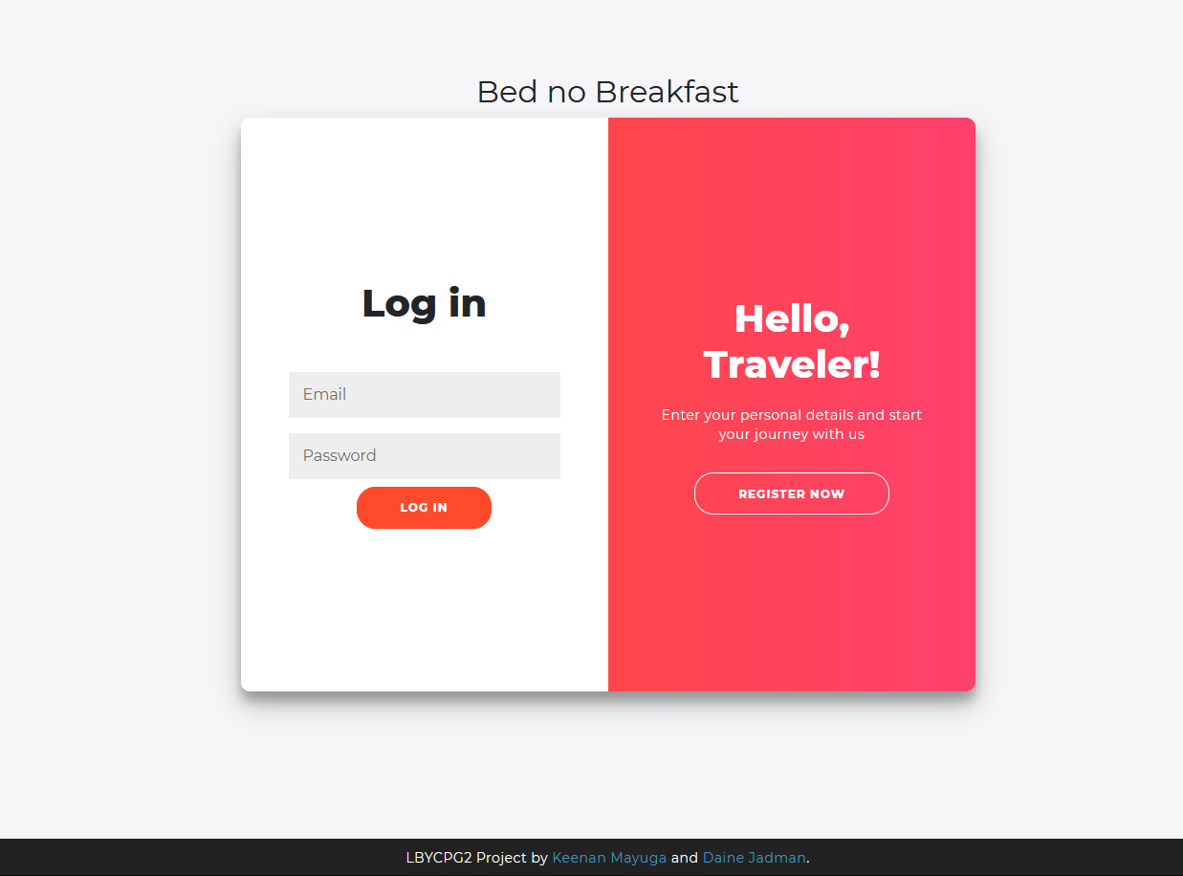

Login Page

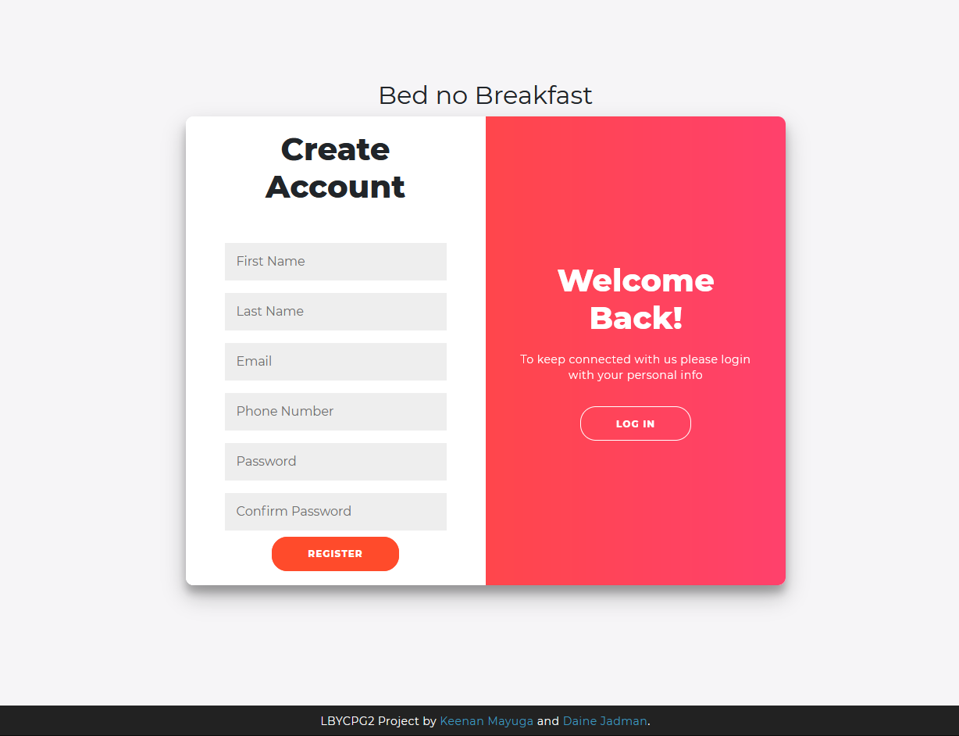

Registration Page

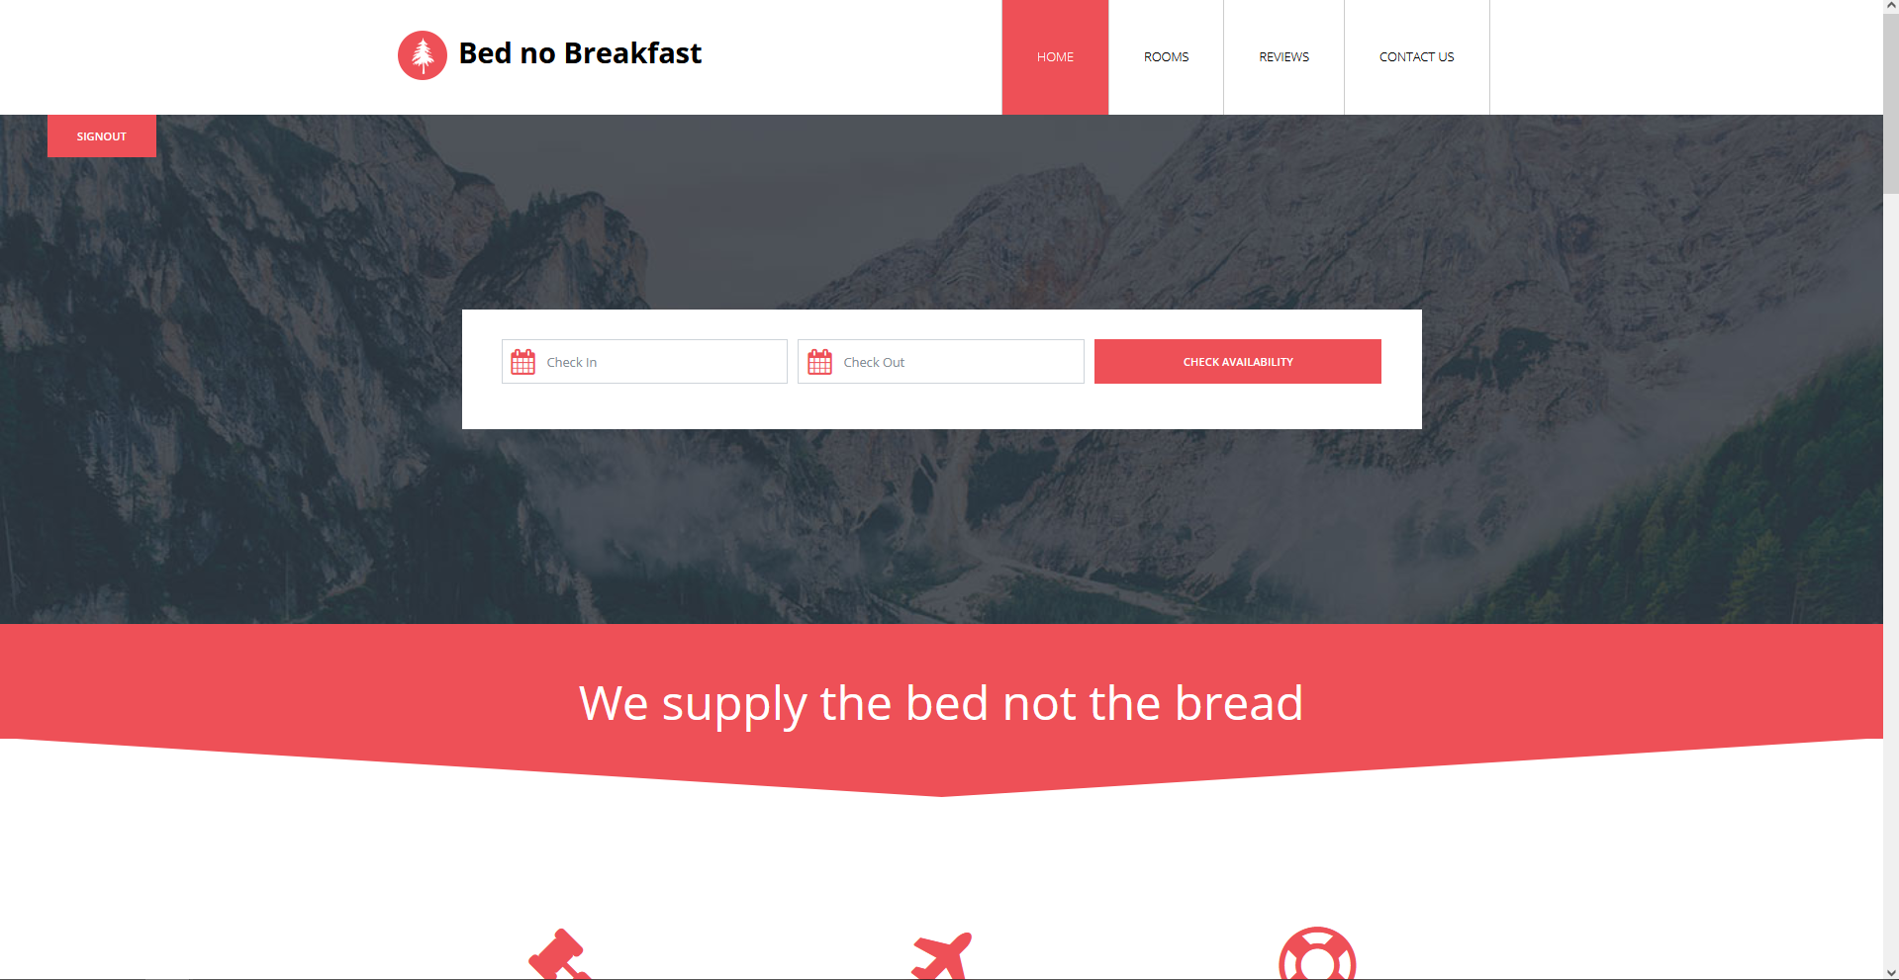

Home Section

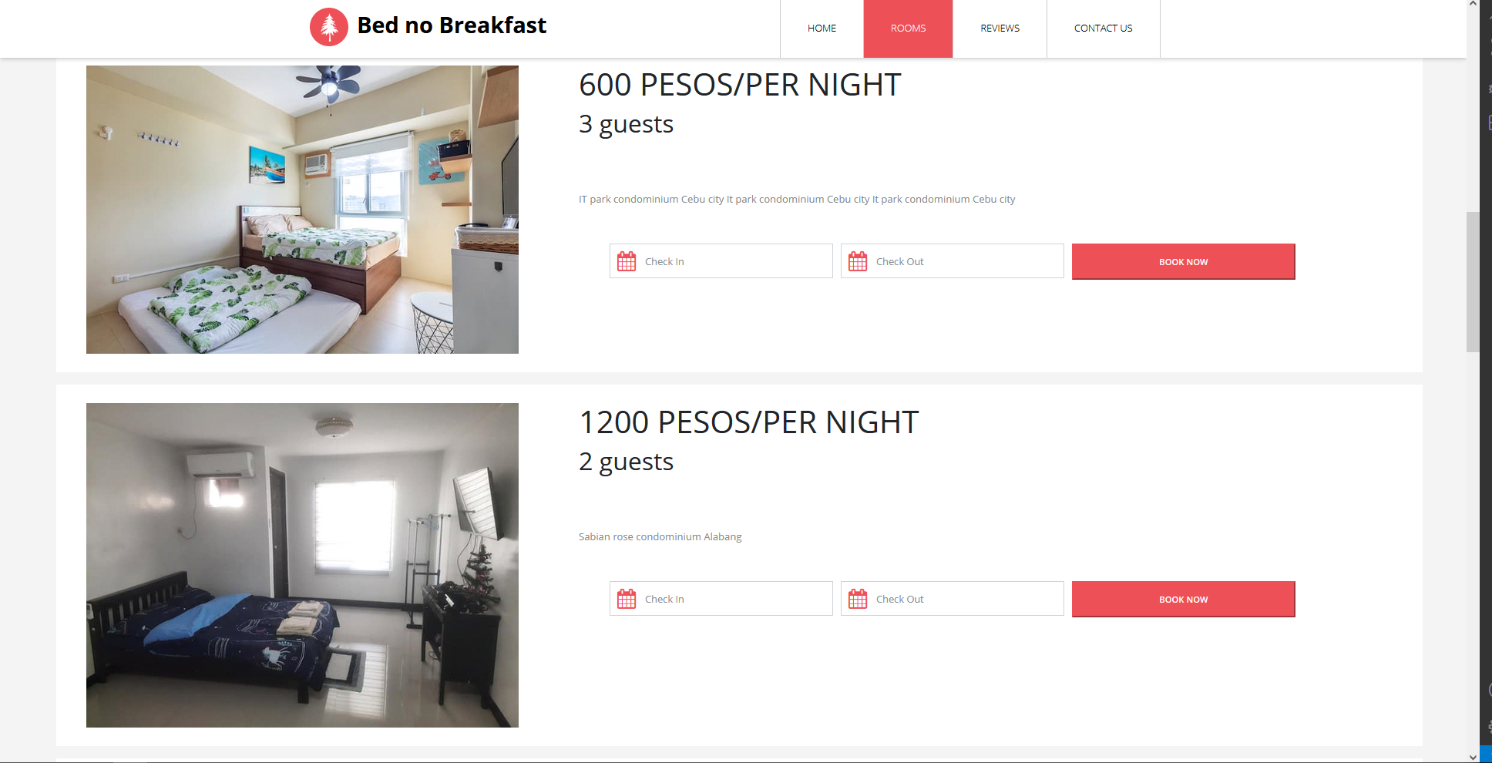

Rooms Section

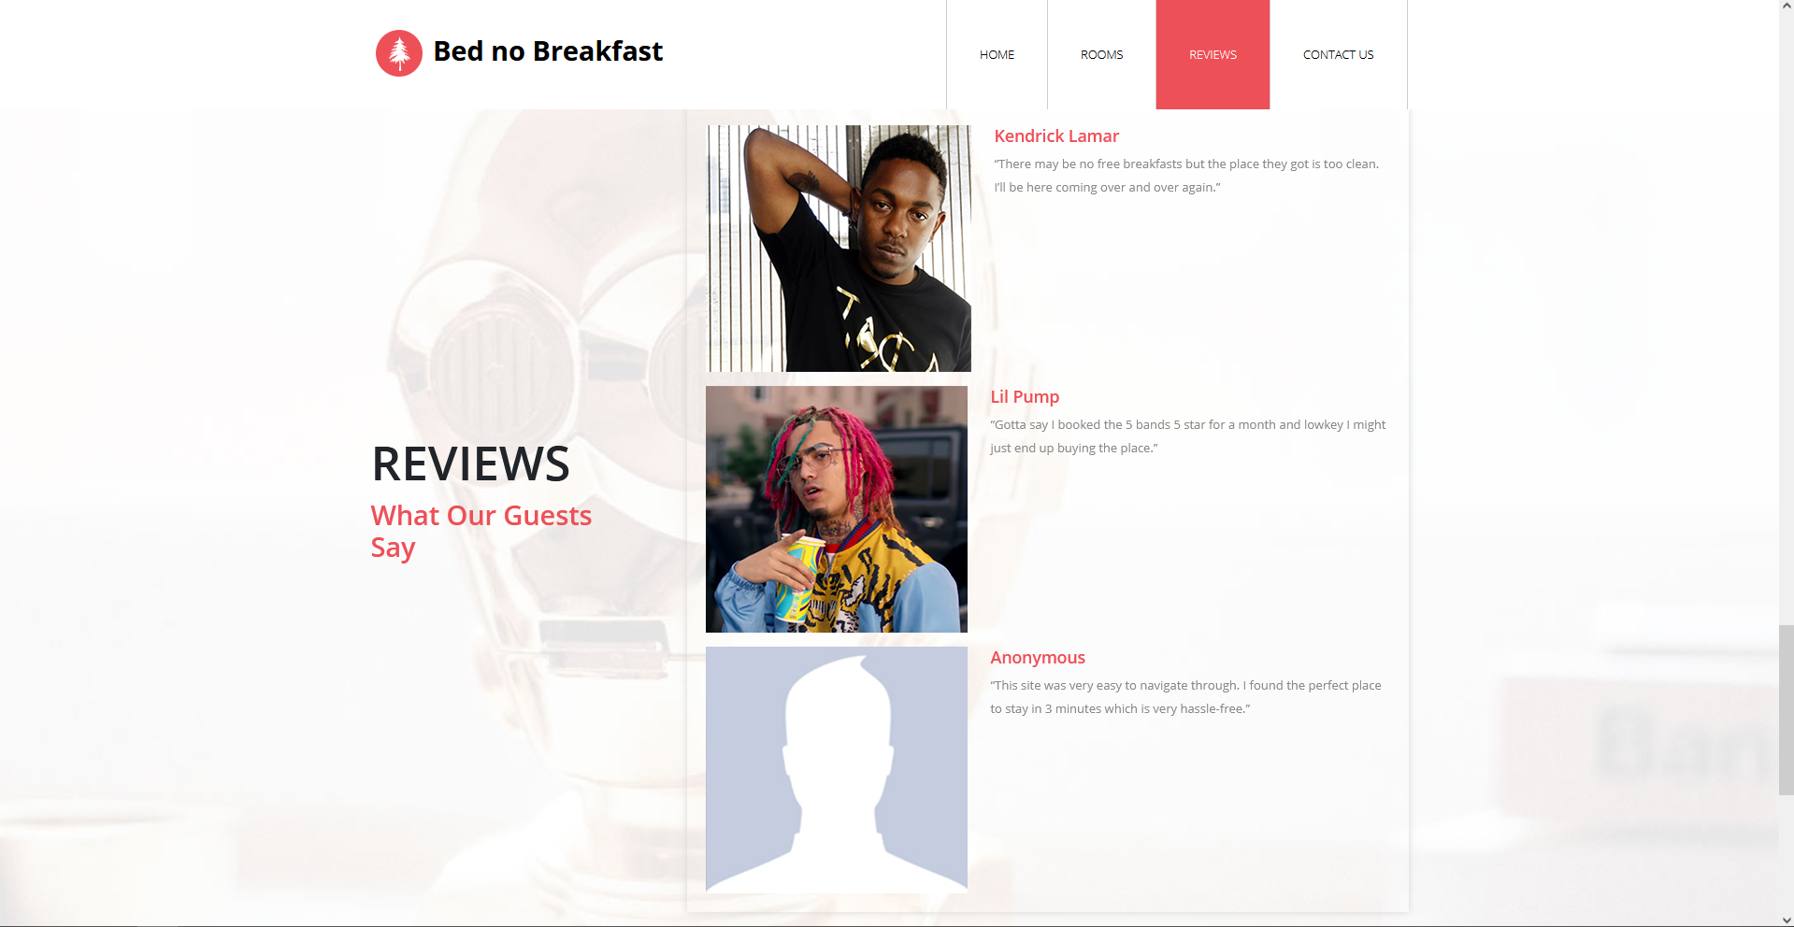

Reviews Section

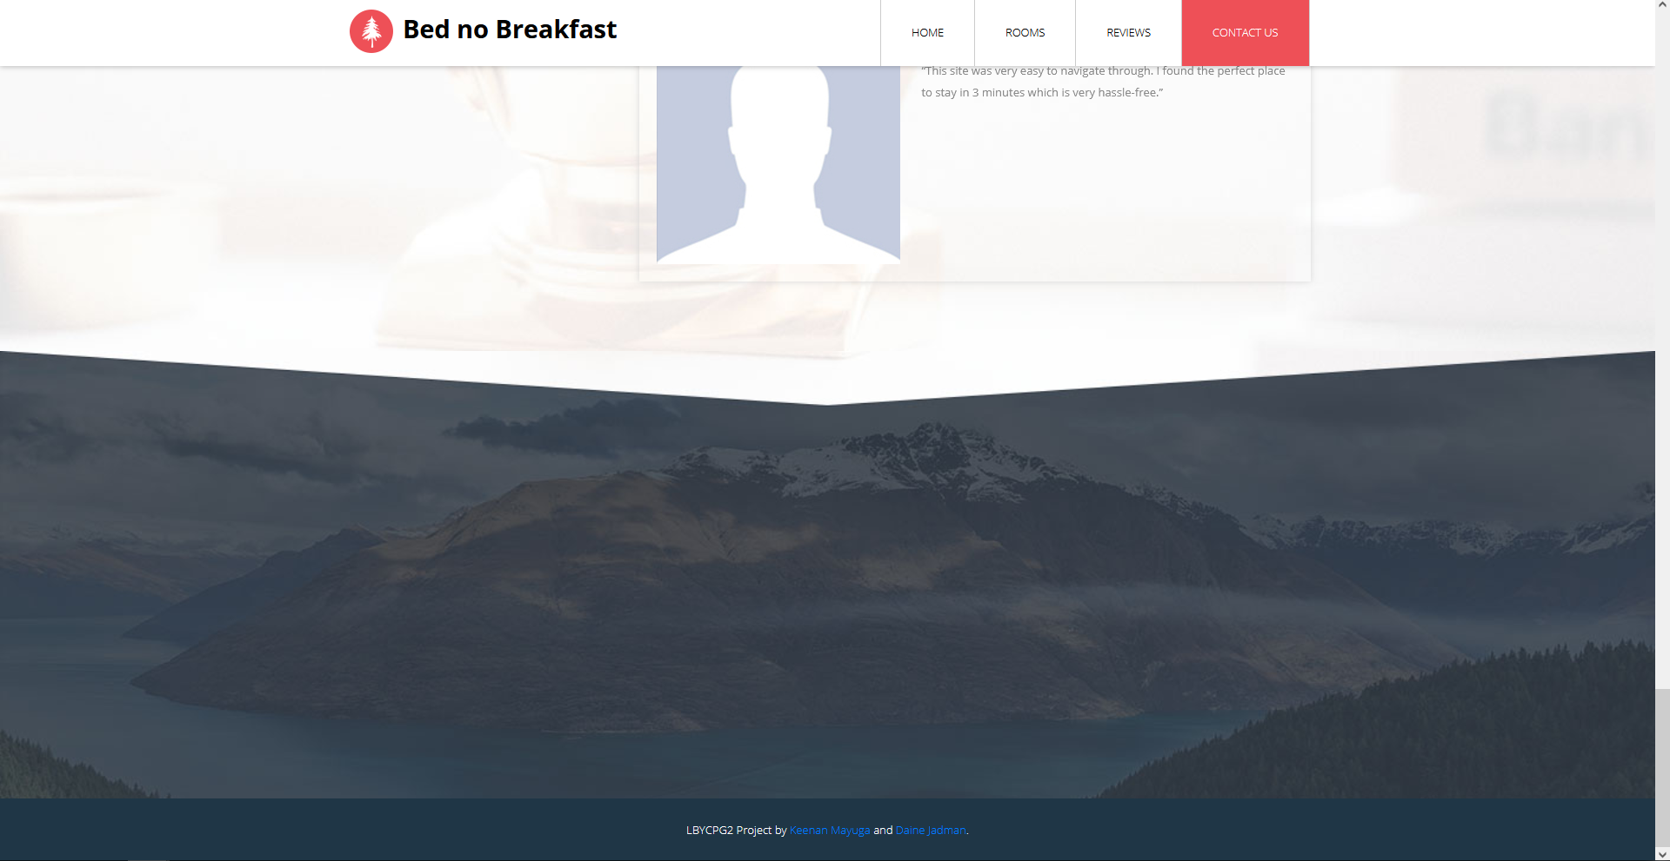

End of Page

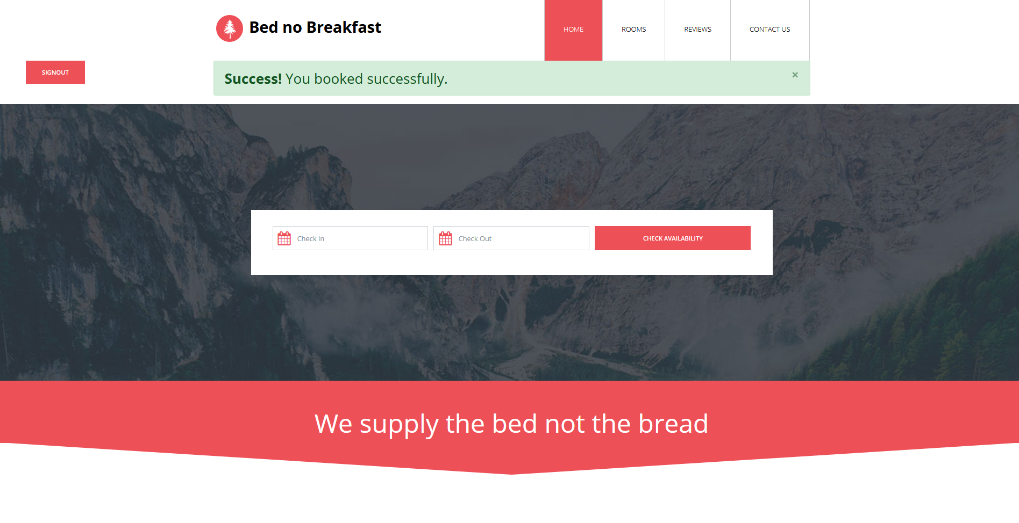

Booking successful